**Purpose :**

version control, clone repositories, So you can either compare your current code file so the current mess that you've made against a previous. Do roll backs. Create push pull requests etc

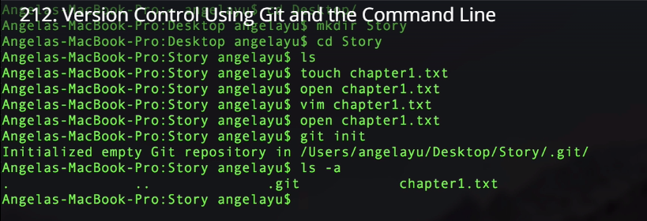

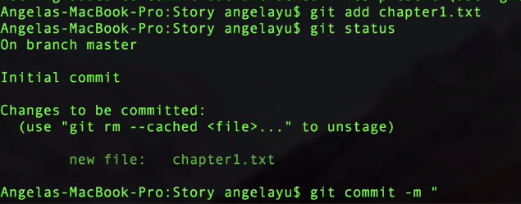



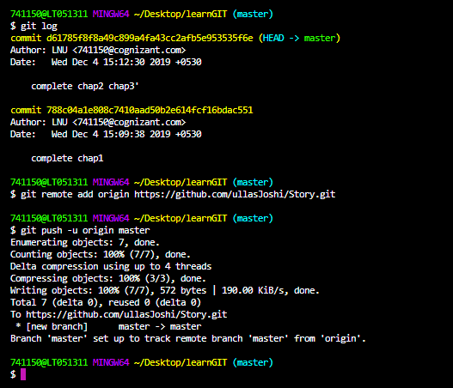

Removing from stating area;

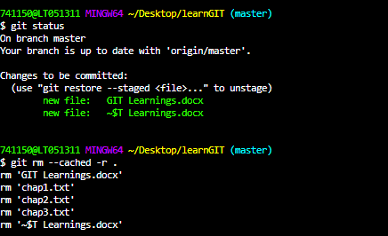

Git Clone:

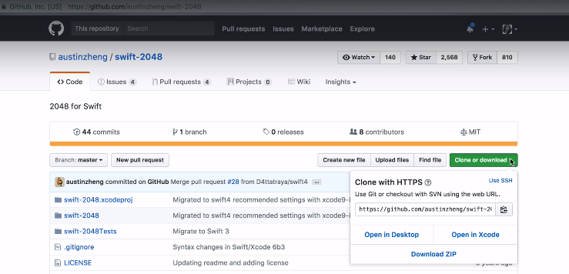

Copy the

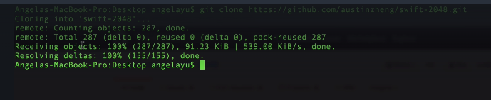

Braching and merging:

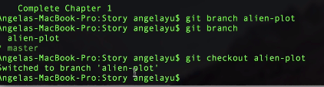

Forking and pull request—

Is when you don’t own the rights to push directly into main repository.

